**Introduction to Software**

**Software Engineering**

1. **What is software?**

**-** Software is a set of instructions (computer programs) that tell a computer what to do. It also includes data structures that help the program work with information and documents that explain how to use the software.

1. **What are the objectives of software engineering?**

**-**

* Understand what users want and create better plans.
* Improve design languages and reusable code.
* Create better interfaces and confirm specifications.
* Improve the quality of software.
* Make software engineers more productive and satisfied with their work.

1. **Importance of Software Engineering?**

**-**

* Reliable and trustworthy software is essential for modern life.
* Planning and engineering methods reduce long-term costs.
* Updating software is a major expense, so good design is crucial.

1. **What is the difference between software engineering and system engineering?\*\*\***

**-** 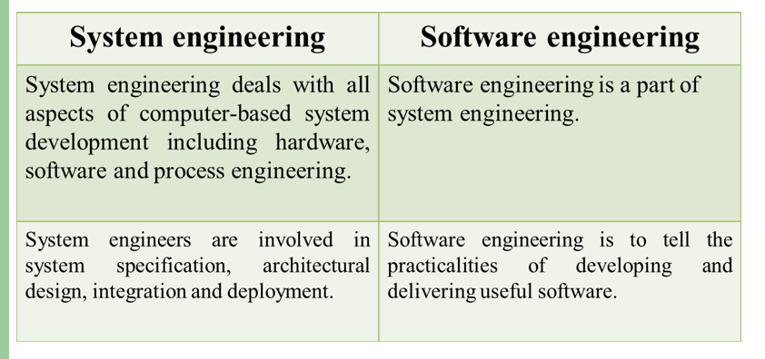

1. **What are the characteristics of software?**

**-**

* Software is developed, not manufactured like physical products.
* Software doesn’t wear out over time like hardware.
* Most software is custom-built, not assembled from pre-made parts.
* High-quality software comes from good design.

1. **Why doesn’t software wear out?/ “Software doesn’t wear out” describe it.\*\*\***

**-** Software doesn’t wear out because it is not affected by environmental factors like dust or temperature. However, it can develop problems if changes are made to it over time.

1. **What are the attributes of good software?**

**-**

**Maintainability:** It should be easy to update and change.

**Dependability:** It should be reliable and trustworthy.

**Efficiency:** It should use system resources wisely.

**Acceptability:** Users should find it easy to use and understand.

1. **What are the different types of software applications?\*\*\***

**-**

* **System software:** Like compilers, editors, and file management tools.
* **Application software:** Programs for specific tasks.
* **Real-time software:** Controls real-world events as they happen.
* **Personal computer software:** Like word processors, spreadsheets, and games.
* **Engineering/scientific software:** Used for complex calculations.
* **Web-based software:** Software that runs on the internet.
* **Embedded software:** Software inside devices like microwaves or cars.
* **Artificial intelligence software:** Solves complex problems using non-numerical methods.